Assignment: Deploy the following 3-tier application architecture on AWS:
Tasks Create a VPC Create one VPC. Create two subnets: One Public Subnet One Private Subnet Deploy the Frontend Launch an EC2 instance in the Public Subnet. Deploy the Frontend application on this EC2. Deploy the Backend Deploy the Backend application on the EC2 in the Public Subnet. Deploy the Database Launch another EC2 instance in the Private Subnet. Deploy MariaDB on this EC2. https://gitlab.com/debjyotimt/e-commerce-app-3-tier
Create VPC – ecom-vpc
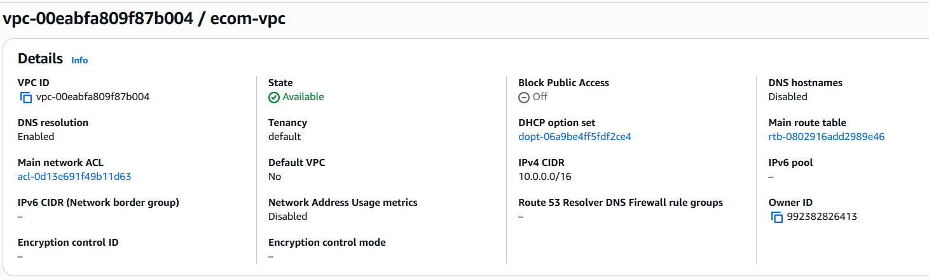

Create public subnet
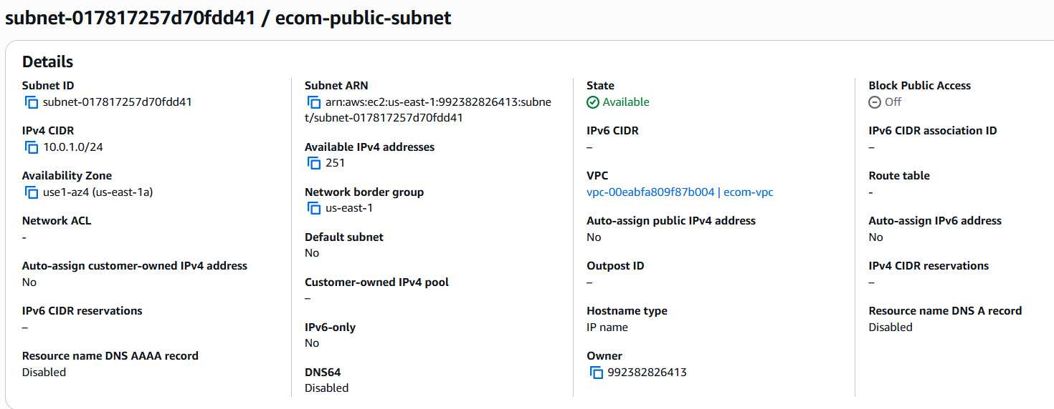
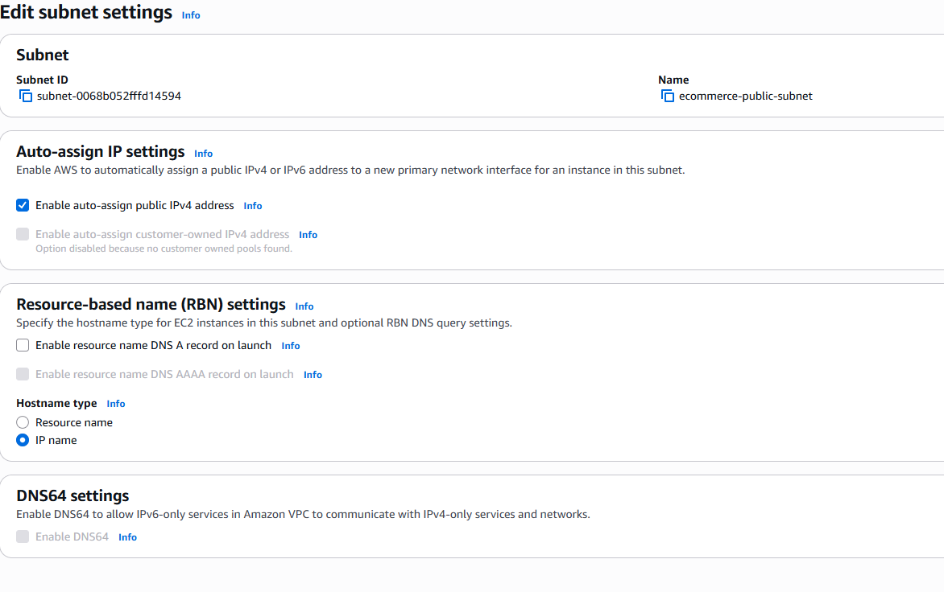
Create private subnet
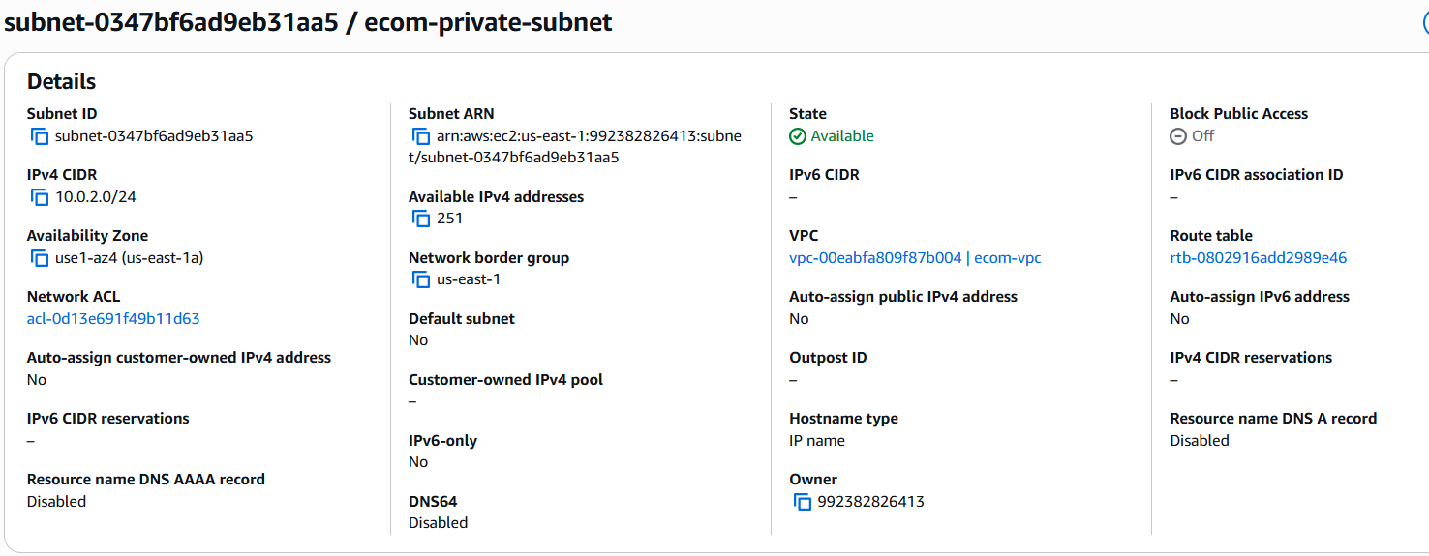
Create Internet Gateway and attach to VPC
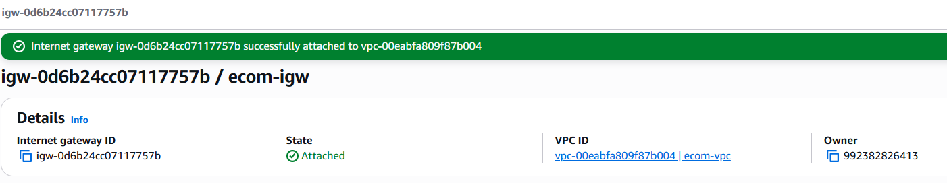
Create public route table associate with public subnet and default route to Internet gateway
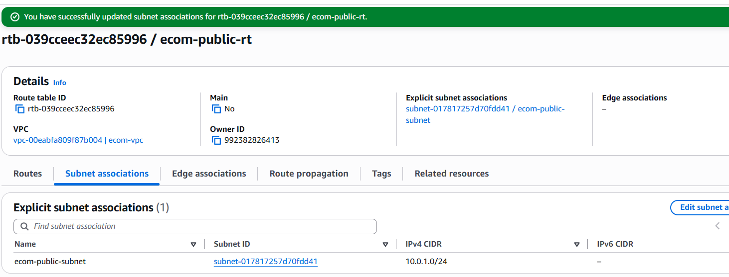
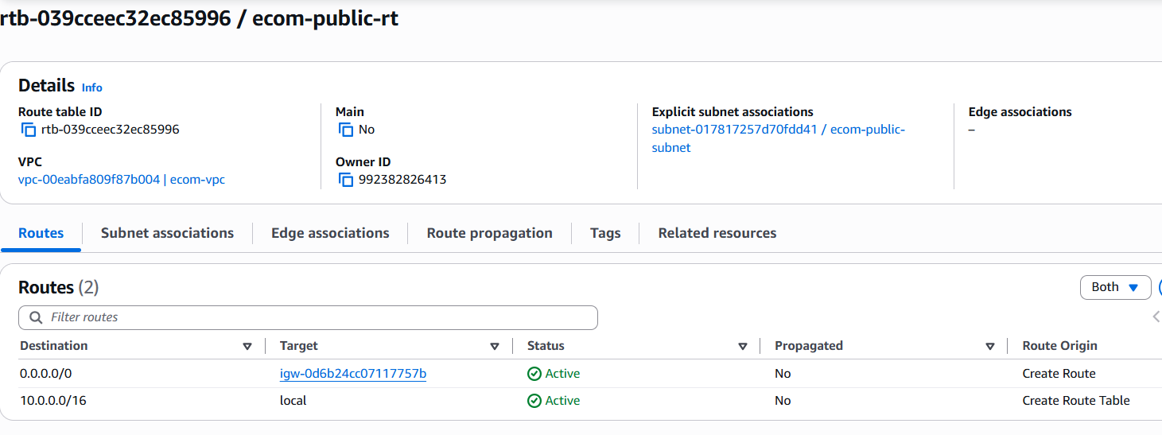
Create Private Route Table and associate to private Subnet
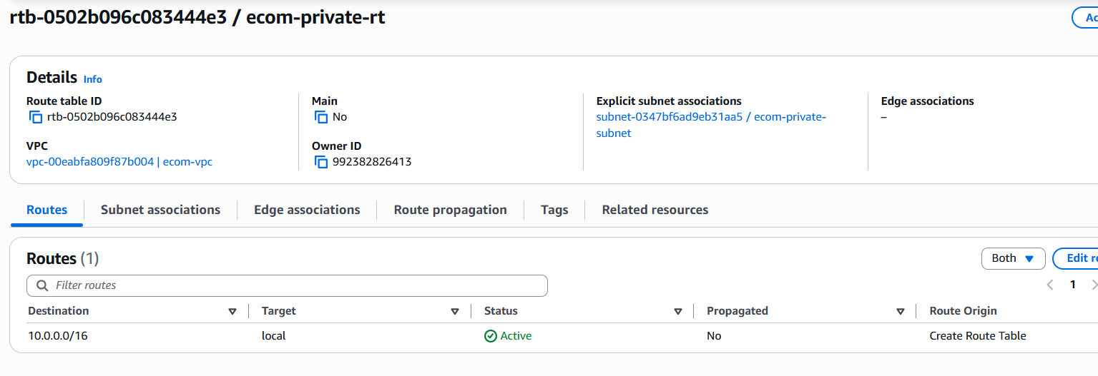
Create nat gateway-VPC-Zonal-subnet-public- - Allocate Elastic IP address – Allocate
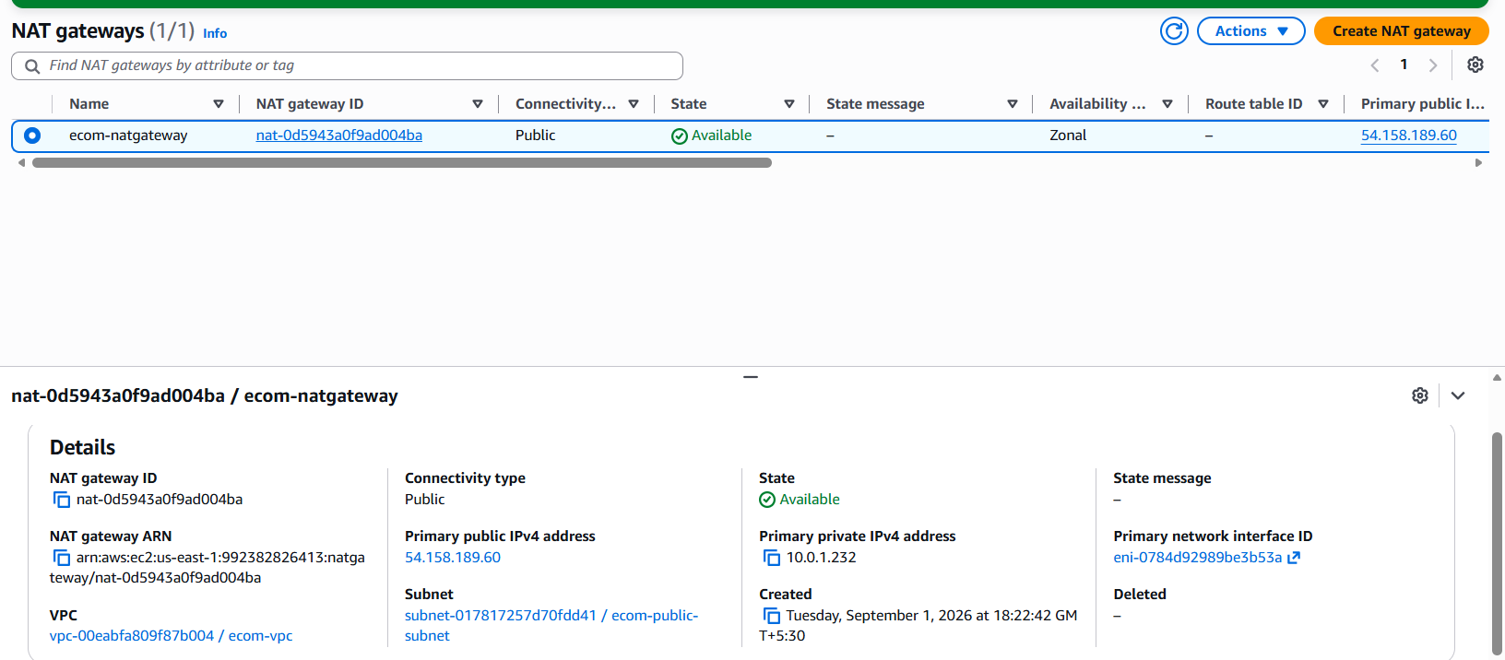
Private Route - edit Route- Target: NAT Gateway
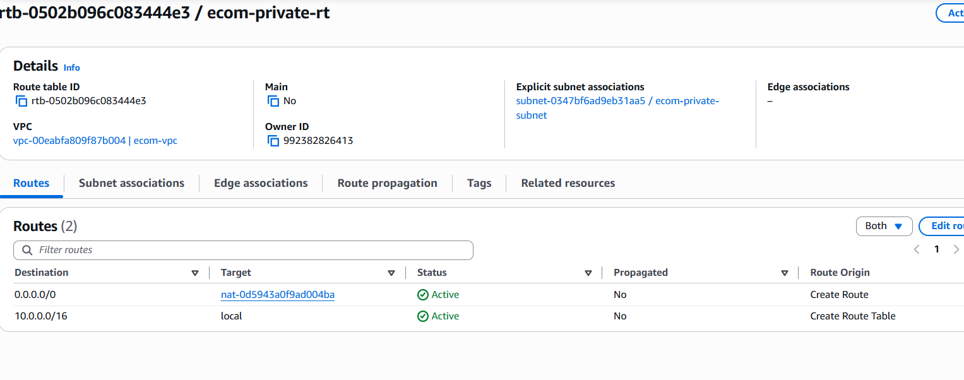
VPC Architecture
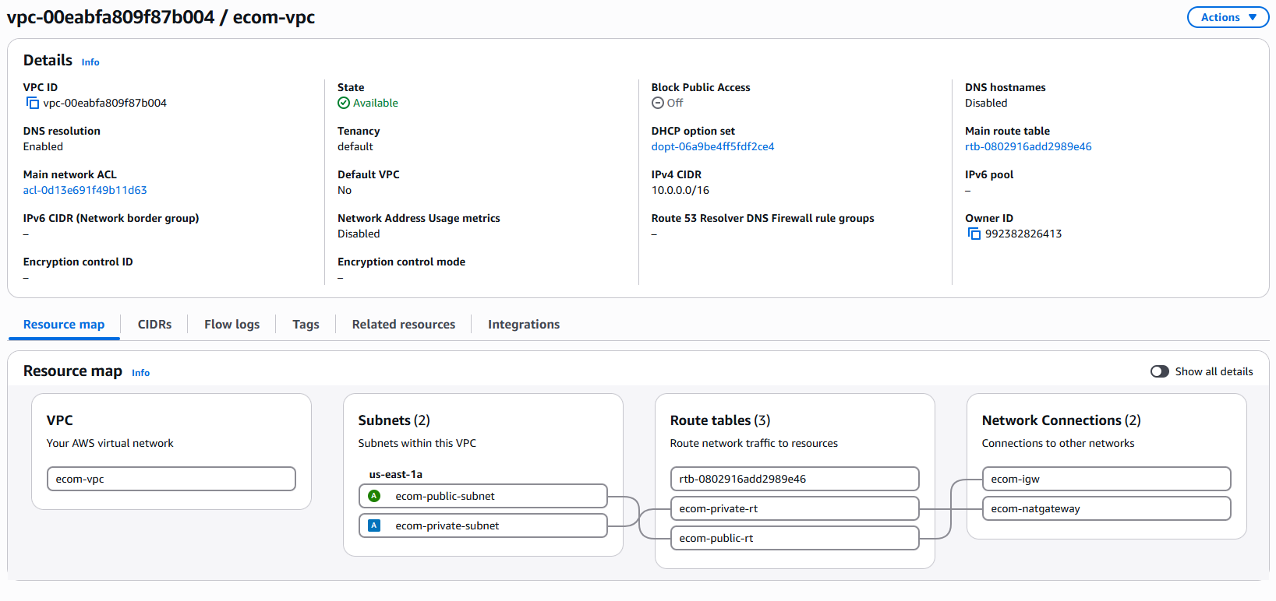
Create Application Security Group
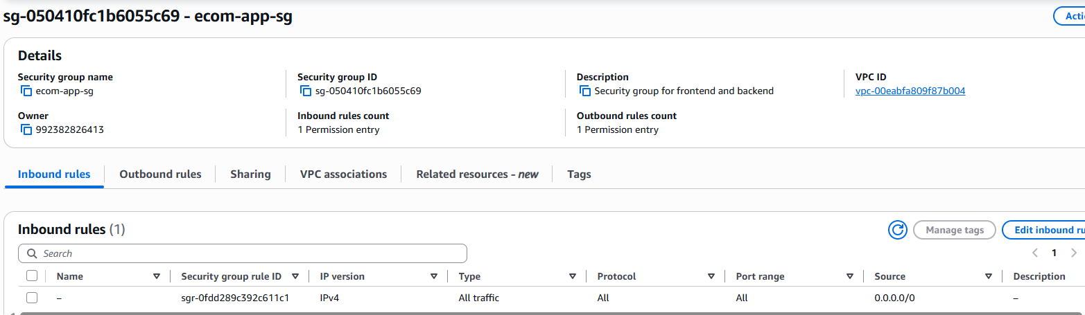
Create Database security group
create inbound rule type – mysql-arora port no 3306- custom to ecomap-sg
and pro
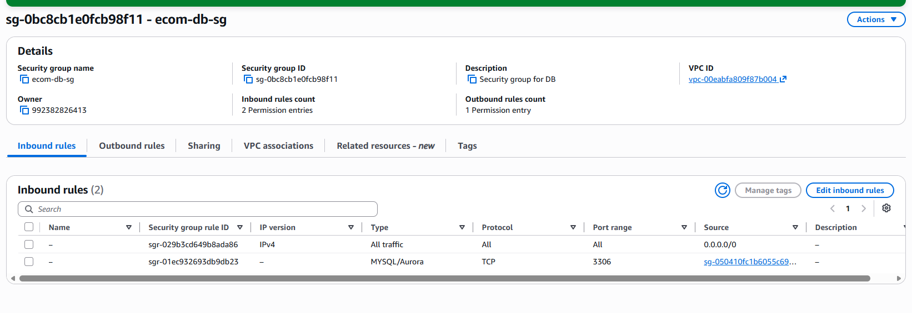
Launch EC2 with Public Subnet
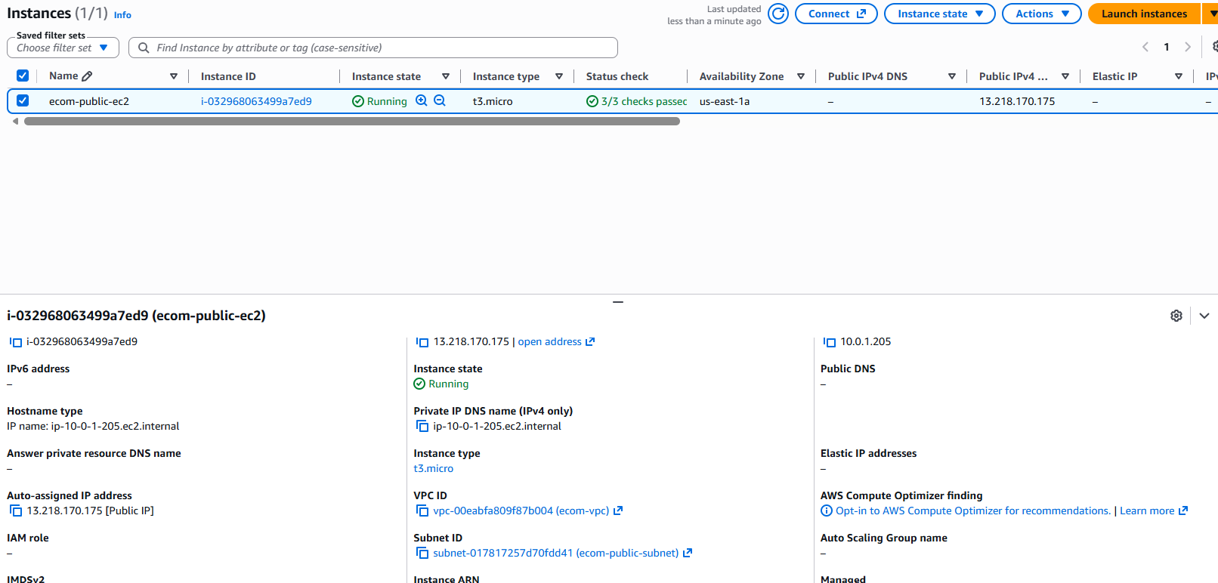
SSH from WSL
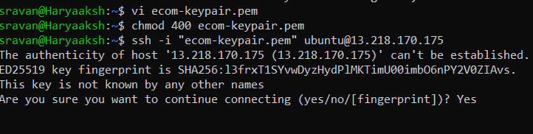
Launch instance-private-ec2-db
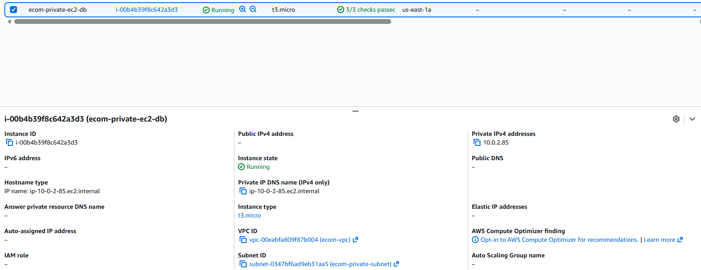
ssh from public ec2 to private ec2
for that first copy add add pen key by using vi in public ec2 then
ssh -i ~/ecom-keypair.pem ubuntu@<ip address of private ec2>
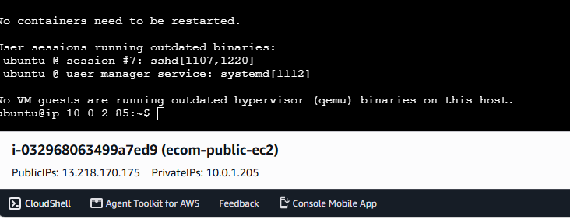
in private ec2 install maria db
sudo apt install -y mariadb-server
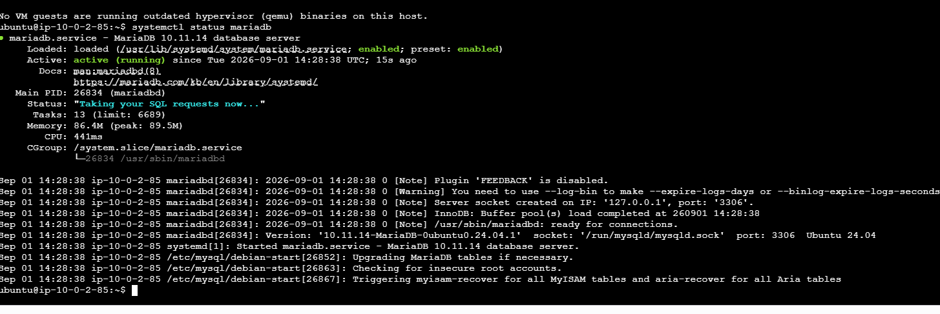
sudo mysql
CREATE DATABASE ecomdb;
CREATE USER 'ecomuser'@'localhost' IDENTIFIED BY 'ecompassword';
GRANT ALL PRIVILEGES ON *.* TO 'ecomuser'@'localhost'; FLUSH PRIVILEGES;
FLUSH PRIVILEGES;
exit
create a database
create a file
sudo vi db-load-script.sql
USE ecomdb; CREATE TABLE products ( id mediumint(8) unsigned NOT NULL auto_increment, Name varchar(255) default NULL, Price varchar(255) default NULL, ImageUrl varchar(255) default NULL, PRIMARY KEY (id) ) AUTO_INCREMENT=1;
INSERT INTO products (Name,Price,ImageUrl) VALUES ("Laptop","100","c-1.png"), ("Drone","200","c-2.png"), ("VR","300","c-3.png"), ("Tablet","50","c-5.png"), ("Watch","90","c-6.png"), ("Phone Covers","20","c-7.png"), ("Phone","80","c-8.png"), ("Laptop","150","c-4.png");
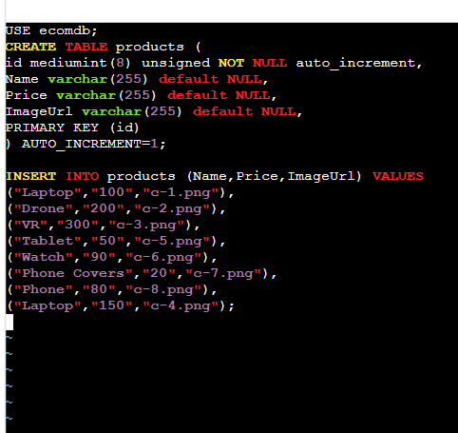
login to db
sudo mysql
SHOW DATABASES;
USE ecoomdb;
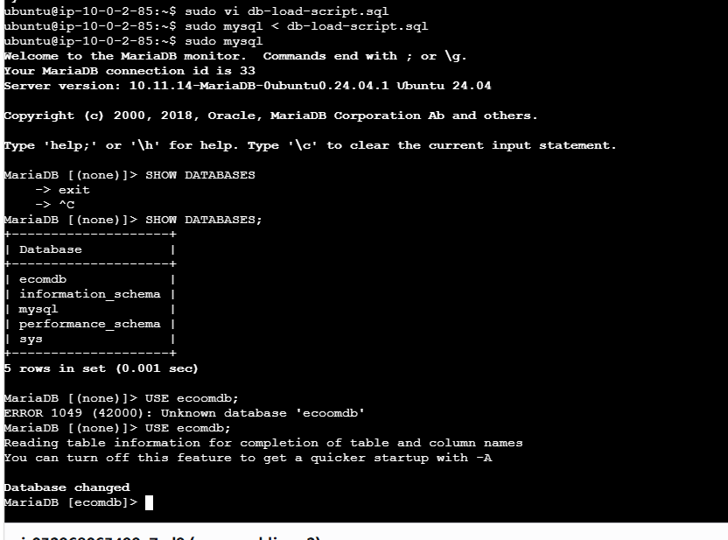
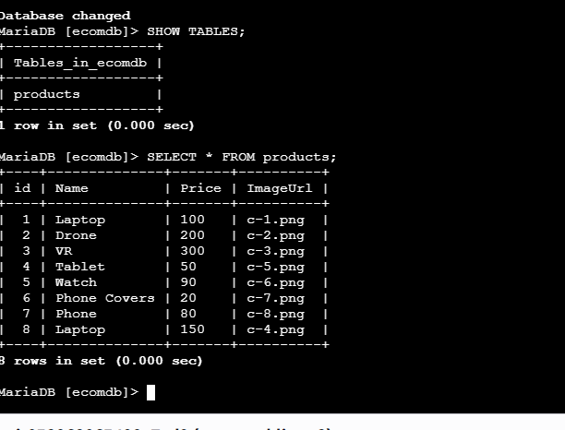
Install apache and php in public ec2
Install Apache & PHP (Web Layer)
Install required packages:
sudo apt install -y apache2 php php-mysql git
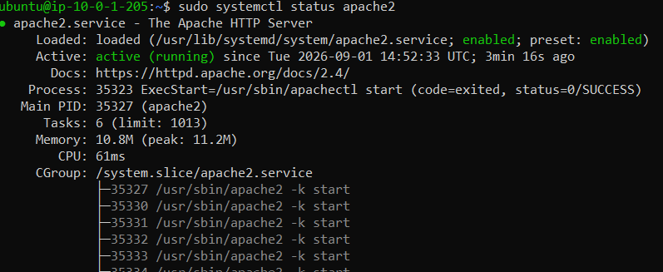
Make sure Apache loads index.php first:
sudo sed -i 's/index.html/index.php/g' /etc/apache2/mods-enabled/dir.conf

Deploy Application Code
Clone the repository into Apache’s web directory:
sudo rm -rf /var/www/html/*
sudo git clone https://gitlab.com/debjyotimt/e-commerce-app-3-tier.git /var/www/html
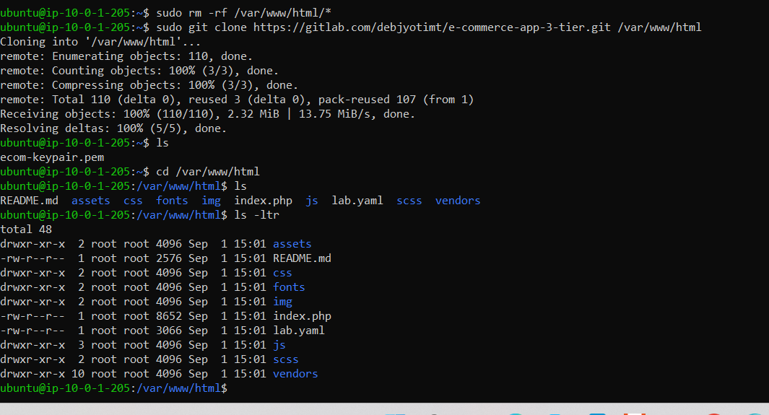
Create Environment File
Create a .env in /var/www/html: sudo vi .env
DB_HOST=localhost
DB_USER=ecomuser
DB_PASSWORD=ecompassword
DB_NAME=ecomdb EOF'
Application Code Notes
The provided index.php already contains code to read values from the environment variables:
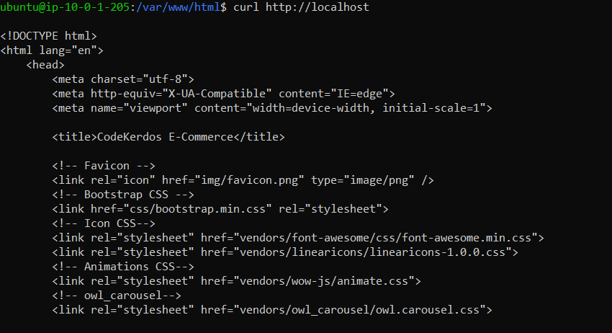


git config --global --add safe.directory /var/www/html

